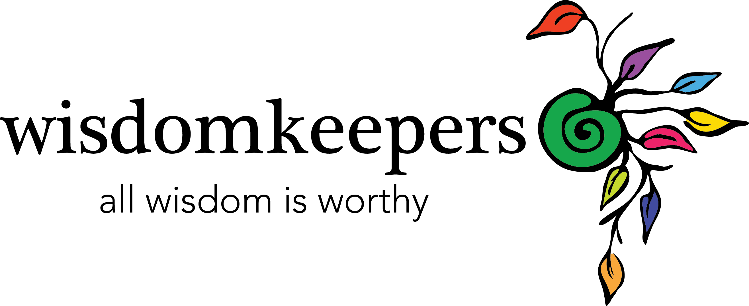
Wisdom Keepers Gathering:
For the Healing of All Our Relations

February 20 – March 20 – Virtual Community, Facebook
March 20, 2015 – Leadership & Support Team Gathering (optional)
March 21, 2015 -- Ceremony in Reno, Nevada North Valleys

Application

Name:

Phone:

Email Address:

Facebook URL:

Mailing Address:

Please provide a BRIEF response below. How would you like The Wisdom Keepers Gathering to support your leadership & spiritual journey? Why do you want to cease this opportunity now?

We have up to two full scholarships available for this event, or the equivalent in partial scholarships. If you would like assistance with tuition, please let us know how much of your $333 tuition you would like covered by scholarship. We will accommodate as much and as many as possible based on the applications.

Please note: Unless you state otherwise, you may be photographed at this event, and these photos may be used in future products and promotions. We have utmost gratitude for your photogenic offerings, but there’s no further compensation for your contribution.

Applications are due by February 14, 2015 | Tuition is due by February 20, 2015

Contact Denise Sheehan, 775.240.0814 or denise@sagespiritcoaching.com for assistance in registering or for more information.

